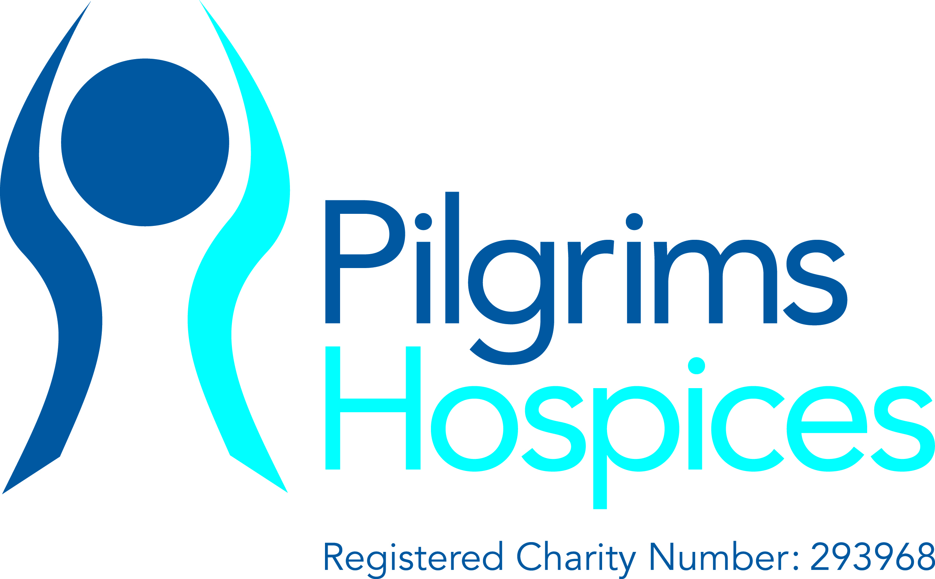

**Advanced Communications Workshop**

This course highlights Effective communication between patients and clinicians is fundamental to the delivery of high-quality end-of-life care.

Through discussions, exercises and the extensive use of role play, this course gives delegates the opportunity to develop, practice and consolidate their clinical communication skills.

**The cost of this course is £499 per person.**

**First name:**

**Surname:**

**Email address:**

**Telephone number:**

**Job Title:**

**Name of the organisation you work for and your band:**

**Department:**

**Date of desired course:**

12th-13th March 2015

12th-13th November 2014

*Please give the details of the person that should be invoiced for the course fee.*

**Name:**

**Address:**

**Please send your completed for to** [**education@pilgrimshospices.org**](mailto:education@pilgrimshospices.org) **or contact 01227 812 616 for more information.**

**Purchase order number if applicable:**

(NHS essential)

**Telephone:**